**Experiment No. 7**

**Code :**

1. **Value**

<html  ng-app="myApp" ng-controller="MyController">

<head>

    <script src="angular.min.js"></script>

</head>

<body>

    <script>

*var* myApp = angular.module('myApp', []);

myApp.value('message', 'Hello, World!');

myApp.controller('MyController', ['$scope', 'message', function($scope, message) {

  $scope.greeting = message;

}]);

    </script>

        <p>{{greeting}}</p>

</body>

</html>

**Output:**

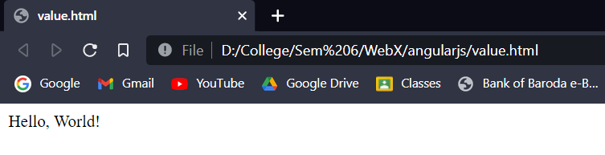

1. **Provider**

<!DOCTYPE html>

<html ng-app="myApp" ng-controller="myController">

<head>

    <script src="angular.min.js"></script>

    <title>Document</title>

</head>

<body>

    <script>

        angular.module('myApp', [])

            .provider("myPro", function() {

                this.$get = function() {

*var* addition = {};

                    addition.add = function() {

*return* 2 + 2;

                    }

*return* addition;

                }

            })

            .controller("myController", function(myPro) {

                console.log(myPro.add());

            });

    </script>

</body>

</html>

**Output :**

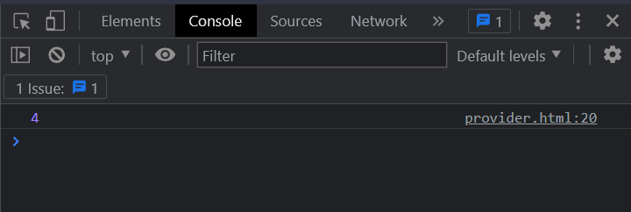

1. **Factory**

<!DOCTYPE html>

<html ng-app="myApp" ng-controller="myController">

<head>

  <script src="angular.min.js"></script>

  <title>Document</title>

</head>

<body>

  <script>

*var* mycore = angular.module('myApp', []);

    mycore.factory("myPro", function() {

*var* data = {};

      data.add = function() {

*return* 10 + 2;

      };

*return* data;

    });

    mycore.controller("myController", function($scope, myPro) {

      $scope.result = myPro.add();

      console.log($scope.result);

    });

  </script>

</body>

</html>

**Output:**

